
[Company Name and Logo]

Emergency Response Plan



Revision: | 0 | Date: | 26/04/2026

TABLE OF CONTENTS
TABLE OF CONTENTS 2
1. GENERAL INFORMATION 4
1.1. Introduction 4
1.2. Aim of the Manual 4
1.3. Amendments 4
2. EVENTS WHICH MAY ACTIVATE THE EMERGENCY RESPONSE PLAN 5
3. DEFINITIONS 6
4. ORGANISATION 7
5. REACTION TO AN EMERGENCY CALL 8
5.1. Emergency Numbers 8
6. SETTING UP THE CRISIS MANAGEMENT CENTRE 10
6.1. Personnel in Charge and Employees 10
6.2. Modes of activating the Crisis Management Centre 10
6.2.1. Accident Occurring on the Company Premises 10
6.2.2. Accident Occurring outside of the Company Premises 10
6.3. Crisis Management Centre - Activation Levels 11
6.4. Activation of the Crisis Management Centre 12
6.5. Crisis Log 12
7. INTERNAL AND EXTERNAL COMMUNICATION 14
7.1. Internal Communication 14
7.2. External Communication 14
8. ROLES OF THE MEMBERS OF THE CRISIS MANAGEMENT CENTRE 17
8.1. Accountable Manager (Chief Executive Officer – CEO) 17
8.2. Flight Operations Manager 17
8.3. Customer Service Representatives 18
8.4. Communication Manager 18
8.5. Safety Manager 18
8.6. Human Resources Department 19
8.7. Legal Department 19
8.8. Maintenance Manager 19
8.9. Security 20
8.10. Logistics/Equipment 20
8.11. Finance Department 21
8.12. Family Assistance Co-ordinator 21
8.13. Secretariat 21
8.14. Useful Contact Details for the Crisis Management Centre 22

GENERAL INFORMATION

Introduction
This Emergency Response Plan was developed on the basis of ORO.GEN.200 and AMC1 ORO.GEN,200(a)(1);(2);(3)(5) point (f) (cf. Section 8.6 of the Safety Management Manual) and is designed to help the organisation to respond in the case of accidents, serious incidents or any other abnormal event triggering a crisis.
The number of phases that need to be implemented must be established in order to prevent the potential confusion that can result when emergency situations arise. Senior management must identify the responsibilities within their organisation, respond to the needs of next of kin of the crew and the passengers, and provide assistance to the emergency services and the authority in charge of any investigation.
This Emergency Response Plan was originally developed for Complex Operators. Non-Complex Operators should adapt the document to the nature and complexity of the Company and its operations. In particular, different roles described in this document may be played the same person. The principle remains the same: Proper Planning Prevents Poor Performance (the 5 P’s)!

Aim of the Manual
The aim of this Emergency Response Planning (ERP) manual is to:
- highlight the policies and procedures to be implemented in case of a crisis,
- offer advice to the members of the crisis management team in carrying out their responsibilities,
- communicate relevant information to employees of the organisation and members of the public.

As opposed to other manuals of the company, the ERP manual is designed to cover crisis situations which cannot specifically or precisely be defined. An organisational framework of the actions and policies required to be implemented is presented. However, it is unlikely that an actual emergency situation will adapt to a precise framework. Adaptability and flexibility should therefore be demonstrated in the handling of such events.

Amendments
This manual will be subject to change. Whenever a change is implemented, the technical manager of the document shall inform all members of the Crisis Management Team and any person(s) who may be called on to play a role in case of an emergency of the change.

EVENTS WHICH MAY ACTIVATE THE EMERGENCY RESPONSE PLAN
The following events may result in a crisis situation and activate the Emergency Response Plan:
- Aviation accident/Serious incident
- Disaster in the premises: fire, explosion, pollution, flood
- Loss of the working resource: workshop, offices, hangar, aircraft
- Impacts of a disaster within the vicinity of the establishment
- Climatic event: snow, storm, flood, lightning
- Natural disaster: earthquake, volcanic eruption
- Food poisoning, epidemic
- Death, suicide at the workplace
- Multiple victims connected to a disaster, illness or contagion
- Accident to the public transportation of the personnel
- Social movements: strike, blocking of the accesses
- Internal or external threat: attack, bomb alert, sabotage, terrorism,
- Loss of energy: electricity, gas
- Loss of communication means: internet, landlines or mobile telephones
- Major media event
- Accident during missions: business trip, abroad.

DEFINITIONS
The definitions below are defined in ICAO Appendix 13, Chapter 1.
Accident: An occurrence associated with the operation of an aircraft which takes place between the time any person boards the aircraft with the intention of flight until such time as all such persons have disembarked, in which:
- a person is fatally or seriously injured as a result of:
  - being in the aircraft, or
  - direct contact with any part of the aircraft, including parts which have become detached from the aircraft, or
except when injuries are from natural causes, self-inflicted or inflicted by other persons, or when the injuries are to stowaways hiding outside the areas normally available to the passengers and crew; or
- the aircraft sustains damage or structural failure:
  - which adversely affects the structural strength, performance of flight characteristics of the aircraft and
  - would normally require major repair or replacement of the affected component, except for engine failure or damage, when the damage is limited to the engine, its cowlings or accessories; or for damage limited to propellers, wing tips, antennas, tires, brakes, fairings, small dents or puncture holes in the aircraft skin; or
- the aircraft is missing or is completely inaccessible.

Incident: An occurrence, other than an accident, associated with the operation of an aircraft which affects or could affect the safety of operation.
Serious incident: An incident involving circumstances indicating that an accident nearly occurred.
Fatal injury: An injury resulting in death within 30 days of the date of the accident.
Serious injury: any injury which is sustained by a person in an accident and which:
- requires hospitalisation for more than 48 hours, commencing within seven days from the date the injury was received; or
- results in a fracture of any bone (except simple fractures of fingers, toes or nose); or
- involves lacerations which cause severe haemorrhage, nerve, muscle or tendon damage; or
- involves injury to any internal organ, or
- involves second- or third-degree burns or any burns affecting more than 5% of the body surface; or
- involves verified exposure to infectious substances or injurious radiation.

ORGANISATION
It is vitally important that an organisation is thoroughly prepared in how to react effectively in the case of an emergency. The progress of events will depend on how the organisation initiates an alert (or relays an alert message).
It is especially important to define a single point of contact (e.g. the operations department) that any member of staff may alert in the case of an emergency. This should include a procedure for out of normal working hours.
This single point of contact will be responsible for disseminating the alert to the company managers and the relevant official authorities.
In order to prevent unnecessary delay, the nominated contact must have immediate access to the following:
- Emergency checklists to cover the nature of the event.
- An up to date list of managers to be contacted and their deputies in the case of absence. (a schedule of 'on-call' executives to be contacted should be created)
- A list of emergency services and official organisations to be contacted in the event of an emergency.

All employees should know their role should a serious event occur including how to raise the alert, immediate first aid drills and what immediate actions to take to try and resolve the crisis or to prevent the situation deteriorating.
It is recommended that organisations carry out regular emergency training exercises to practice and refine their procedures and to train personnel.
Wherever possible the normal activity of the organisation must be maintained. To this end, employees whose activity is not affected by the situation should continue to carry out their normal duties. Personnel should, however, contact their family and friends to reassure them in an attempt to prevent an influx of external communications.
If the presence of an employee is not required at the accident/incident site, or at the location of the Crisis Management Team, they should be discouraged from going to these locations so as not to hinder the emergency services and/or any investigation team(s).
It is important that personnel not involved in the management of the situation do not contact the Crisis Management Team or speak to the media.

REACTION TO AN EMERGENCY CALL
Whenever the Company is made aware of an accident or incident, the person or department that receives the alert must endeavour to establish the following information points:
  - Date and time of the call.
  - Name and contact details of the informant.
  - Establish the authenticity of the call (where possible).
  - In the event that the call is made anonymously, try and obtain information concerning the other party and their position. (where possible, try to record the conversation and listen to background noise).
  - If the call is being made from overseas, check the location of the call with the embassy of the country in question.
  - Initiate the alert process both in-house and externally.

Emergency Numbers
The direct contact details for the members of the Crisis Management Team and the Emergency Services must be readily accessible and up to date.
An example of the departments/persons to be contacted on a priority basis in case of event of an emergency is given below.

IN-HOUSE
- Accountable Manager (CEO) (or deputy)
- Operations Manager
- Safety Manager
- Maintenance Manager
- Communication Manager
- Legal Manager
- Human Resources Manager

EXTERNALLY
- The Search and Rescue Co-ordination Centre (RCC) (in the event of an aircraft accident or aircraft overdue).
- The Air Traffic Control Centre
- The Maritime or Coast Guard Service (in the case where the aircraft has been engaged in over water operations).
- Emergency Medical Services.
- Fire and Rescue Service.
- Police.

The elements outlined above are summarised in the Primary Accident Information Sheet on the following page.
PRIMARY ACCIDENT INFORMATION SHEET
Date
Time
Details of the person giving the alert
Aircraft Details
- Type
- Registration
- Persons on Board (Crew/Pax)
Location of the accident
Brief circumstances of the accident
Consequence for the crew

Bodily and property
Consequences for passengers

Bodily and material
Consequences for third parties on ground

Bodily and material
Consequences for the aircraft

Description of damage
Other Information

SETTING UP THE CRISIS MANAGEMENT CENTRE

Personnel in Charge and Employees
Depending on the size of the organisation, some individuals may have several responsibilities. However, a certain number of skilled employees should be grouped within the Crisis Management Centre and they must be under the control of designated representatives of the organisation.
Suitable accommodation within the organisation offices must be dedicated as the Crisis Management Centre and equipped to deal with emergency situations. A suitable scale of equipment is described in the paragraph 'logistics/equipment' in Chapter 4.

Modes of activating the Crisis Management Centre

Accident Occurring on the Company Premises
Any person who witnesses an accident on the organisation's premises should be able to comply with the following fundamental safety rules:
  - Alert the designated person within the Crisis Management Team
  - Alert the emergency services (where appropriate)'
  - Protect any victims/casualties,
  - Where qualified, apply basic first aid while awaiting the arrival of the emergency services.
It is important that each employee of the organisation knows both the on-call and emergency numbers.

Accident Occurring outside of the Company Premises
Case 1: The call is received by the On-Call Manager
The On-Call Manager informs the CEO who decides whether or not to activate the Crisis Management Centre.
The On-Call Manager contacts the members of the Crisis Management Centre.

Case 2: The call is received by an employee of the organisation
The employee contacts the On-Call Manager or, if the On-Call Manager is unavailable, a member of senior management of the organisation who will decide whether or not to activate the Crisis Management Centre. (See figure 1)
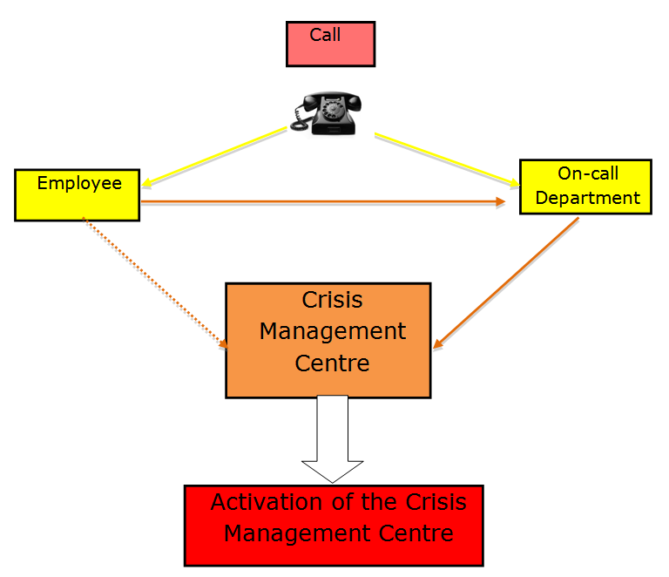
Figure 1 – Activation of the Crisis Management Centre

Crisis Management Centre - Activation Levels
Level 1: Event with potentially hazardous impact but without immediate consequences
The members of the Crisis Management Team are placed on alert in order to reduce the response time should the situation deteriorate. At this level of preparedness, the Crisis Management Team members should be contactable and available at all times.

Level 2: Event that may have one or more significant impacts on the safety of people or property, and on the normal state of operation of the company.
Members of the Crisis Management Team should be called to Crisis Management facility in order to have a preparatory decision, and thereby be in a position to react immediately.

Activation of the Crisis Management Centre
Members of the team should initiate the 'cascade' alert system as scheduled (cascade) and report to the crisis cell equipped with the following:
- Business mobile phone
- Crisis management file containing the Emergency Checklists to be followed and the actions to be carried out.
- Laptop computer, if required.
- An adequate supply of writing material such as notebooks, pencils, pens, etc.

An example of how to 'man up' the Crisis Management Centre is shown at figure 2.
Please adapt as necessary.

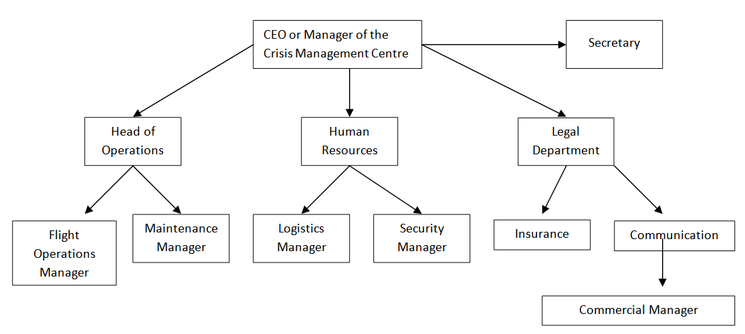
Figure 2 – Composition of the Crisis Management Centre

Crisis Log
Once the Crisis Management Centre has been activated, all events, decisions and subsequent actions must be recorded in a Crisis Log. This will ensure that an accurate record of actions taken in response to the emergency situation is retained.
An example of a crisis log is given on the next page.

CRISIS LOG

Description of the event:
Date of the event: |  |  |  | Time of the event:
Location of the event:
Activation date of the crisis management centre: |  |  |  |  |  | Time:
Composition of the Crisis Management Centre:  - Manager of the company  - Human Resources manager  - Legal manager  - Communication manager  - Operations manager  - Maintenance manager  - ... |  |  |  |  | Names: |  | Contact:
Person in charge of drawing up the log:
DATE | TIME | EVENT | DECISION |  |  | ACTIONS | REMARKS
Crisis Log P... / .....

INTERNAL AND EXTERNAL COMMUNICATION

Internal Communication
In responding to an emergency situation, all or part of the organisations personnel may be affected by the event, depending on the size of the company.
Senior management must make a concerted effort, by whatever means appropriate, to inform all personnel regarding the event.
Senior management must in a timely manner inform the personnel of the steps to be taken for managing the crisis.
The organisations policies, such as a ban on disclosing any information outside of the organisation, and the policy for dealing with the media should be reinforced. Additionally, there should restrictions placed on personnel to prevent them attending at the accident/location or at the Crisis Management Centre, unless required to do so within the scope of their duties.
Volunteers from within the organisation may sought to assist in dealing with families and friends of the victims. In such circumstances it is important to anticipate this type of request, and to have launched a request for volunteers during the normal activities of the organisation. It is desirable to have a pre-selected list of volunteers in order to in a position to react quickly when the need arises.
Additionally, it is important that the organisation has in place a list of specialists such as psychologists and councillors who may be contacted to provide professional assistance to the victim's relatives, employees and volunteers as appropriate.

External Communication
In the situation where a major event has occurred, it is essential that the organisation implements a detailed communication plan under the guidance by the Legal Department or, where such a department is not in place, a lawyer appointed by the organisation for that purpose.
Once an emergency call has been received and the Crisis Management Centre has been manned, an initial press release should be disseminated in an attempt to prevent the saturation of lines of communication. Press releases should not contain the name(s) of the persons involved in the accident/incident unless they have been definitively established.
Additionally, the names of senior or departmental managers should not be released unless authorised.
Examples of press releases are set out as follows:

INITIAL PRESS RELEASE

PRESS RELEASE FROM __________

Place __________, Date ___________

It has been reported that ______________Air Traffic Control lost contact with a _________
(Insert Type) helicopter at _________ (Insert Time) today ___________(Insert Date).
The helicopter was being operated by _____________ (Insert Company Name) and it was
en route from _____________ to _____________.

Initial reports indicate that the helicopter was carrying ____ people on-board including ____ crew members.

The management and staff of __________ (Insert Company Name) would like to extend our deepest sympathy to the family and friends of the passengers and flight crew involved.

At this stage we have no further information concerning the circumstances of the accident and _____________ (Insert Company Name) is not in a position to speculate on the cause of this tragedy. ___________ (Insert Company Name) is currently working with the relevant authorities in order to identify how the accident happened.

(An emergency contact telephone number for relatives and friends should be provided if available)

Further statements will be issued once details become available.
PRESS RELEASE - UPDATE

PRESS RELEASE FROM ______________

Place ____________, Date _____________

OPERATING CREW

_____________ (Insert Company Name) can confirm that the identity of the flight crew
involved in the _____________ (Insert Type) helicopter accident that occurred on
____________ (Insert Date) in the vicinity of ____________(Insert Location).

(Briefly outline the names of the operating crew including ages, years of service and total experience levels if available).

LIST OF PASSENGERS

(Give names of passengers, their age and nationality if known).

Specially trained personnel have been provided to offer support and assistance to the families and friends of both passengers and crewmembers and we would request that members of the media respect their privacy during this difficult time.

____________ (Insert Company Name) is continuing to work with the authorities and will continue to provide further information as and when it becomes available.

ROLES OF THE MEMBERS OF THE CRISIS MANAGEMENT CENTRE
The following sets out some of the roles and responsibilities required to be carried out by a Crisis Management Centre.
These roles and responsibilities should be developed in the form of a checklist in the interest of efficiency and clarity. (This list is not exhaustive and an organisation should tailor or expand the list to suit their organisation).
Roles to be covered:
- Accountable Manager (Chief Executive Officer - CEO)
- Flight Operations Manager
- Customer Services representative
- Safety Manager
- Human Resources
- Legal Department
- Maintenance Manager
- Security
- Logistics/Equipment
- Finance Manager
- Family Assistance Co-ordinator
- Secretariat

The list of nominated persons and the attribution of roles may vary according to the size and organisation of the Company. Certain employees for instance may fulfil several roles within the Crisis Management Centre. Please provide a list adapted to your Company.

Accountable Manager (Chief Executive Officer – CEO)
Manage internal operations by relying on the members of the crisis management centre
in conjunction with the communication manager and the legal department/lawyer , draft the releases to the media. Appoint a spokesperson to communicate with the media. Where possible he should not do this himself.
Ensure that the activities of the company are maintained if these activities are not affected by the event.
Be at the disposal of the relevant official organisations.

Flight Operations Manager
Gather any information relative to the flight and the nature of the activity relative the accident.
Compile a list of all documents relating the flight and have them available fort the authorities including:
- Copies of weather reports
- Copies of pre-flight planning documents
- Copies of Weight and Balance planning
- Copies of fuel planning and fuel uplift receipts
- Copy of the passenger manifest

Compile a list of the administrative documents pertaining to the crewmembers involved including as a minimum:
- Individual Training Files
- Flight Time and Duty Records
- Logbook (if available)
- Copies of medical certificates
- Copies of flight crew licences

In co-operation with the Maintenance Manager, gather the technical documents relating to the aircraft involved in the accident
If required, select and brief crews to fly investigators, police or authorised persons of the organisation to the accident site.

Customer Service Representatives
Contact the customer(s) affected by the accident in accordance with any contractual agreements in place.
Contact any sub-contracted companies affected by the accident, where appropriate.

Communication Manager
Provide the interface between the organisation and the press , ensuring that only relevant and accurate information is provided without prejudicing the investigation in any way.

Safety Manager
Collect data from the Company SMS and safety database(s) regarding previous occurrences and risk assessments, mitigation and control (various risk controls in place) concerning the safety risk(s) revealed by the event at hand.
Provide analysis on previous occurrences and risk assessments to the Accountable Manager and Communication Manager, to enable them to answer any questions correctly to support the protection of company reputation.
Assist the Accountable Manager and the Communication Manager in any other way.
Be at the disposal of the relevant official organisations.
Update SMS information (after the crisis).

Human Resources Department
Carry out a short briefing of personnel to advise them of the situation and of the actions to be taken
Assist in establishing a list of casualties involved in the accident.
Compile a list of all HR documents relating to the staff members involved in the accident, and have them available for the authorities.
Ensure that any personnel assigned to carry out any duty at the accident location are provided with the necessary logistics and equipment.
Initiate the organisations plan for dealing with the emotional trauma of personnel and, if necessary, contact the medical professionals and/or the counselling teams designated.
Contact employees who have volunteered to assist in dealing with the families of victims.

Legal Department
Examine and vet any statements drawn up by the Communications Department or senior management prior to them being issued.
Provide information as applicable on legal issues pertaining to the accident.

Maintenance Manager
Compile a list of the administrative documents relating to maintenance of the aircraft involved in the accident and its continuing airworthiness (C of R, C of A, ARC, equipment log, engine log, etc.), along with all records of maintenance carried out on the aircraft and its systems including:
- airframe
- engine(s)
- MGB
- Rotor and rotor head
- Anti-torque rotor
and have it available for the investigating authorities.
Compile a list of information concerning the maintenance personnel, and have it available for the investigating authorities including:
- Copies of licences
- Training records

Provide technical support to the members of the Crisis Management Centre
Assist the investigating authorities with technical expertise when requested.
Participate in organising the protection of the accident scene and the recovery of the wreckage (airframe, engine(s) and other components), if so requested by the authorities in charge of the investigation.

Security
Limit access to the offices and headquarters of the organisation, including surrounding areas. This should include any premises of offices dedicated to the investigation authorities.
Ensure that the identity and baggage of all persons entering/leaving the organisation are checked. Where appropriate, provide escorts for non-organisational personnel.
Check that other buildings and areas are secured (Hangars, Ramps, etc.)
Where members of the media have been authorised to enter the establishment, ensure that they are escorted and controlled at all times.
Where required, establish a security perimeter around the scene of the accident prior to the arrival of the investigating authorities.

Logistics/Equipment
Provide and maintain appropriate scales of communications equipment:
- Televisions
- Video recorders
- Computers/Internet connection
- Printers
- Fax
- Landlines and mobile telephones

Ensure that the company website, where appropriate, is updated.
Liaise with the Crisis Management Centre, senior and departmental managers to ensure that all logistical requirements needed to support the operation are provided including:
- Transport
- Accommodation
- Refreshments and catering
- Personal protective equipment
- Specialist equipment (lighting, lifting equipment, etc.)
- Mobile telephones

Finance Department
Ensure that appropriate levels of financial support are available to the employees assigned to attend at the accident site.
Ensure that an appropriate level of financial support is provided to cope with immediate needs of the victims and their families.
Set up a specific account to handle financial dealings relating to the accident, and establish accurate estimates of the anticipated costs related to the accident.

Family Assistance Co-ordinator
Ensure that appropriate facilities are provided within the organisation's offices or at a location close to the accident site to receive the families of victims.
Ensure that appropriate communications links (telephone, etc.), tables and chairs, paper and pens, magazines, refreshments, etc. are made available for the families of the victims.
Where necessary, ensure that overnight accommodation is available for families.
Select volunteers from within the pool of employees who have indicated that they will provide assistance to the relatives and friends of the victims.
Identify the receiving hospital(s) for both victims and casualties and when required provide transport for the families.
Maintain contact with those relatives of the victims who are unable to attend at the site.
Liaise with the HR Department regarding the provision of grief/trauma counselling for the families of the victims.

Secretariat
Provide secretarial services to the Crisis Management Team and senior management including:
- Answering telephones
- Internet communications
- Updating the Crisis Log
- Maintaining a list of persons contacted
- Drafting of press releases or other communiqués.

Useful Contact Details for the Crisis Management Centre
A list of useful contact details should be compiled and included in the Crisis Management Manual. This should include experts in the following areas:
- Medical
- Public Health
- Dangerous Goods
- Environmental
- Etc.

Additionally a list should be compiled covering logistical support services:
- Travel (airline, maritime, rail, hire car, taxi, etc.)
- Accommodation (hotels, portable accommodation, etc.)
- Catering
- Clothing/Equipment supplies
- Heavy lifting
- Haulage
- Photographic
- Etc.

